OOP LAB1 ASSIGNMENT

**Q1.**

#include <iostream>

#include <iomanip>

using namespace std;

int main(){

double wght,pound;

cout<<"Enter the weight of a person in kg: ";

cin>>wght;

pound=wght*2.2;

cout<<fixed<<setprecision(2)<<"The weight of the person in pound is: "<<pound<<endl;

}

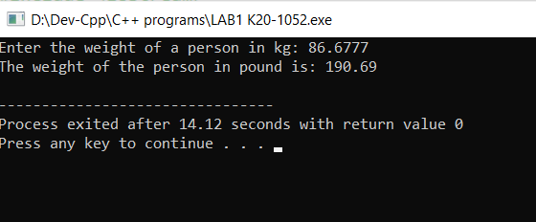

**Q2.**

#include <iostream>

using namespace std;

int main(){

char mname[50];

int noadtic,nochdtic,ttic;

double padult,pchild;

double grossamount,damount,pgross,nsale;

cout<<"Enter the movie name: ";

cin.getline(mname,50);

cout<<"Enter the price of adult ticket: ";

cin>>padult;

cout<<"Enter the price of child ticket: ";

cin>>pchild;

cout<<"Enter the no of adult tickets: ";

cin>>noadtic;

cout<<"Enter the no of child tickets: ";

cin>>nochdtic;

cout<<"Enter the percentage of gross amount to be donated to charity: ";

cin>>pgross;

ttic=(noadtic + nochdtic);

grossamount=(padult*noadtic + pchild*nochdtic);

damount=(grossamount*pgross)/100;

nsale=grossamount-damount;

cout<<"******************************************************************** "<<endl;

cout<<"Movie name is: "<<mname<<endl;

cout<<"No of tickets sold are: "<<ttic<<endl;

cout<<"Gross amount is: $ "<<grossamount<<endl;

cout<<"Percentage of gross amount donated: "<<pgross<<"%"<<endl;

cout<<"Amount donated: $ "<<damount<<endl;

cout<<"Net sale: $ "<<nsale<<endl;

}

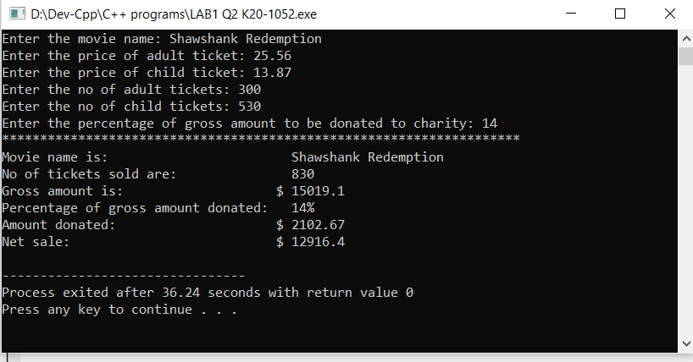

**Q3.**

#include <iostream>

#include <iomanip>

using namespace std;

struct stdinfo{

char name[50];

double marks[5];

double avg;

};

int main(){

stdinfo s1;

int i;

double sum;

cout<<"Enter the name of the student ";

cin.getline(s1.name,50);

cout<<"Enter the 5 test scores"<<endl;

for(int i=0;i<5;i++){

cin>>s1.marks[i];

}

for(int i=0;i<5;i++){

sum = sum + s1.marks[i];

}

s1.avg=sum/5;

cout<<endl;

cout<<"Student name is: "<<s1.name<<endl;

cout<<"Test scores: ";

for(int i=0;i<5;i++){

cout<<fixed<<setprecision(2)<<s1.marks[i]<<" ";

}

cout<<endl;

cout<<fixed<<setprecision(2)<<"The average test score is: "<<s1.avg;

}

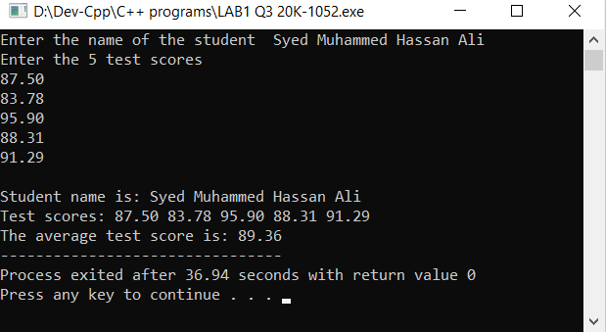

**Q4.**

#include <iostream>

#include <iomanip>

#include <string>

using namespace std;

struct menuItemType

{

string menuItem;

float menuPrice;

};

int main(){

cout << "\t\tWelcome to Johnny's Restaurant";

int a[8]= {0,0,0,0,0,0,0,0},choice,qty;

char ques;

double total, tax, gross;

menuItemType menuList[8];

menuList[0].menuItem = "Plain Egg";

menuList[0].menuPrice = 1.45;

menuList[1].menuItem = "Bacon and Egg";

menuList[1].menuPrice = 2.45;

menuList[2].menuItem = "Muffin";

menuList[2].menuPrice = 0.99;

menuList[3].menuItem = "French Toast";

menuList[3].menuPrice = 1.99;

menuList[4].menuItem = "Fruit Basket";

menuList[4].menuPrice = 2.49;

menuList[5].menuItem = "Cereal";

menuList[5].menuPrice = 0.69;

menuList[6].menuItem = "Coffee";

menuList[6].menuPrice = 0.50;

menuList[7].menuItem = "Tea";

menuList[7].menuPrice = 0.75;

cout << endl << endl << "Breakfast items offered by the restaurant are" << endl;

cout << 1 << "\t" << menuList[0].menuItem << setw(12) << "$. " << menuList[0].menuPrice << endl;

cout << 2 << "\t" << menuList[1].menuItem << setw(8) << "$. " << menuList[1].menuPrice << endl;

cout << 3 << "\t" << menuList[2].menuItem << setw(15) << "$. " << menuList[2].menuPrice << endl;

cout << 4 << "\t" << menuList[3].menuItem << setw(9) << "$. " << menuList[3].menuPrice << endl;

cout << 5 << "\t" << menuList[4].menuItem << setw(9) << "$. " << menuList[4].menuPrice << endl;

cout << 6 << "\t" << menuList[5].menuItem << setw(15) << "$. " << menuList[5].menuPrice << endl;

cout << 7 << "\t" << menuList[6].menuItem << setw(15) << "$. " << menuList[6].menuPrice << endl;

cout << 8 << "\t" << menuList[7].menuItem << setw(18) << "$. " << menuList[7].menuPrice << endl;

do{

cout << endl << "Enter your choice: ";

cin >> choice;

cout << endl << "Enter the Quantity: ";

cin >> qty;

switch(choice){

case 1:

{

a[0] = a[0] + qty;

cout << "You have Selected :" << menuList[0].menuItem << endl;

break;

}

case 2:

{

a[1] = a[1] + qty;

cout << "You have Selected: " << menuList[1].menuItem << endl;

break;

}

case 3:

{

a[2] = a[2] + qty;

cout << "You have Selected: " << menuList[2].menuItem << endl;

break;

}

case 4:

{

a[3] = a[3] + qty;

cout << "You have Selected: " << menuList[3].menuItem << endl;

break;

}

case 5:

{

a[4] = a[4] + qty;

cout << "You have Selected: " << menuList[4].menuItem << endl;

break;

}

case 6:

{

a[5] = a[5] + qty;

cout << "You have Selected: " << menuList[5].menuItem << endl;

break;

}

case 7:

{

a[6] = a[6] + qty;

cout << "You have Selected: " << menuList[6].menuItem << endl;

break;

}

case 8:

{

a[7] = a[7] + qty;

cout << "You have Selected: " << menuList[7].menuItem << endl;

break;

}

default:

cout << "invalid input" << endl;

}

cout << endl << "Enter (y/n) to select more items: ";

cin >> ques;

} while (ques != 'n');

cout << "\n\n" << "********RECIPT********\n" << endl;

for (int i = 0; i < 8; i++){

if (a[i] > 0){

cout << a[i] << "\t" << menuList[i].menuItem << " " << menuList[i].menuPrice << "$"<< endl;

total = total + (menuList[i].menuPrice*a[i]); }

}

tax = total*0.05;

gross = total + tax;

cout << "\tTax " << "\t" << tax << "$" << endl;

cout << "***********************************************" << endl;

cout << "Total Amount is " << fixed << setprecision(2) << gross << "$" << endl;

cout << "***********************************************";

return 0;

}

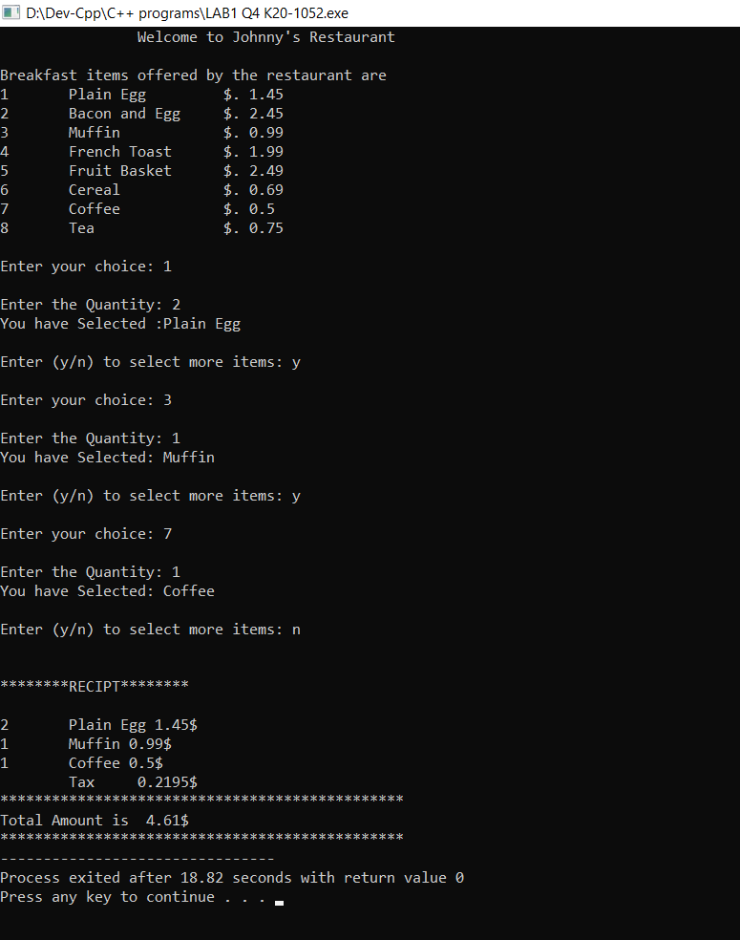

**Q5.**

#include <iostream>

using namespace std;

struct playerData

{

string name;

int homeRuns;

int hits;

int id;

};

int main()

{

playerData player[10];

int arr[10];

int i,idd,choice;

cout<<"1- For storing the data of baseball players\n2- For finding the info of a certain player stored in index\n3- For finding the index of a specific player, and update the data of a player.\n4- For showing the info of all players\n\n";

do{

cout<<"Input the choice ";

cin>>choice;

switch(choice){

case 1:

cout<<endl;

for(i=0; i<2; i++)

{

cout << "Enter name of the player " << i << ": ";

cin >> player[i].name;

cout << "Enter the number of home runs: ";

cin >> player[i].homeRuns;

cout << "Enter the number of hits: ";

cin >> player[i].hits;

cout << "Enter the id of player: ";

cin >> player[i].id;

cout<<endl;

}

break;

case 2:

cout<<endl;

cout << "Enter the ID of the player for searching: ";

cin >> idd;

for(int i=0 ;i<2; i++){

if(idd == player[i].id){

cout<<"Name: "<<player[i].name<<endl;

cout<<"Home runs: "<<player[i].homeRuns<<endl;

cout<<"Hits: "<<player[i].hits<<endl;

}

}

break;

case 3:

cout<<endl;

cout << "Enter the ID of the player to change the data: ";

cin >> idd;

cout<<endl;

for(int i=0 ;i<2; i++){

if(idd == player[i].id){

cout<<"Enter the new Name of player: ";

cin>> player[i].name;

cout<<"Enter the new home runs of player: ";

cin>> player[i].homeRuns;

cout<<"Enter the new hits for player: ";

cin>> player[i].hits;

}

}

break;

case 4:

cout<<endl;

cout<<"The detail of each player is\n";

for(int i=0 ;i<2; i++){

cout<< "Name: " << player[i].name<<endl;

cout<< "Home runs: "<< player[i].homeRuns<<endl;

cout << "Hits: "<< player[i].hits<<endl;

}

default:

cout<<endl;

cout << "Enter the correct choice\n";

}

cout<<"If you want to do further task enter correct choice else it will terminate\n";

}

while(choice >= 1 || choice <=4);

return 0;

}

